**Q4:**

Can you detail your Automation framework to automate an end –end scenarios from a web application to mobile application and vice versa.

Assume the scenario is that you have booked a cargo to deliver from Goa to Delhi using a front office web application and you have received a shipment number.

Now the delivery team has a mobile application using which they keep updating the status of the shipment as – Started from Source station, On Route, Delivered in Destination.

As the delivery team updates the status on the mobile app, this status should reflect in the web application when you track the shipment number as a user.

**Answer** :

I would like to go with the cucumber framework with page object model approach. Below is the typical architecture of the same:

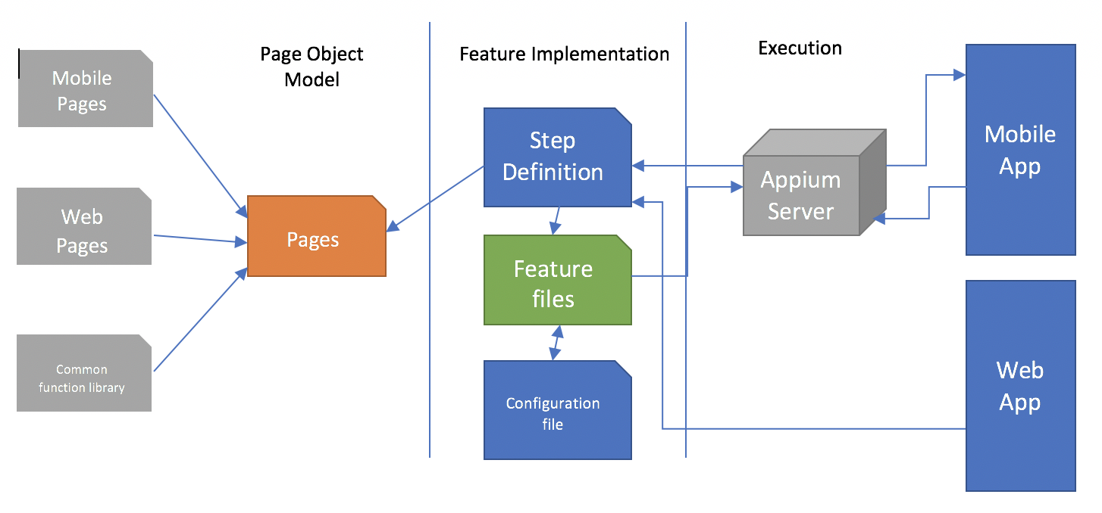

**Page Object Model :**

Page Object Pattern technique provides a solution for working with multiple web/mobile pages and prevents unwanted code duplication and enables an uncomplicated solution for code maintenance. In general, every page in our application will be represented by a unique class of its own and the page element inspection will be implemented in every class.

**Feature Implementation:**

The tests written in gherkin format ( Given/When/Then ) format has to have the definition linked to it . This will ensure that the individual step has a valid definition and can be reused if the same step is coming in the other test flow.

These step definitions files may use the configuration files in order to use some global variable.

**Execution:**

User can have multiple test runs to execute the type of test they want to execute. In my test I have created two different test runs by providing different tags (e.g. @flightStatus, @flightSearch ). These test runs are responsible for executing multiple features and also create the reports in json format in the target folder.

**Case study:**

As I can see the end to end test is involving both web and mobile based application in the same flow. Therefore it should be covered in one feature. I will instantiate to separate drivers (Web and Appium) .Web driver will be responsible to execute the web part and then the result can be stored into a config file so that it can be reused in the rest of the flow.

The shipment number will be stored into a config file (e.g. properties or xls ). After that the mobile flow to update the status will be executed with the shipment number stored. Once the mobile flow is completed the execution of web can be resumed to see the changes or track the shipment number in the web.

We have to be careful with waits we are going to use as there can be challenges related to the synchronisation between the web and mobile apps.